Technical Artefact 2 — Dataset Preparation & Data Engineering Report

UNSW-NB15 Source-Domain Preparation

Technical Lead: Labannya Barua — Student ID: 12280502

COIT20265 | Group PG3 | HT2 2026
Dataset Preparation & Data Engineering

Repository and source code: https://github.com/Labannya22/COIT20265

1. Executive Summary
This artefact covers the data engineering work behind our group’s intrusion detection system: turning the UNSW-NB15 benchmark into a dataset our six unsupervised models could actually be trained on, and could later be run on with traffic from our own lab.

Three constraints shaped every decision. The models are one-class, so they can only be trained on normal traffic. They must eventually score Zeek connection logs, so they can only use features Zeek can also produce. And the result has to be reproducible by anyone on the team from the two raw CSV files.
The work produced a fitted preprocessor, a fixed 41-column feature order, and four processed arrays — 41,065 normal training records, 10,266 normal validation records, and two test sets of 82,332 and 80,995 records.
Four findings came out of the preparation itself.

The duplicate audit materially changed the experimental design. When identifier/label fields were excluded from the comparison, 74,072 training rows and 28,380 testing rows belonged to duplicate-equivalent groups. In addition, 8,541 test rows overlapped records in the training partition, including 1,193 normal test records matching normal training records. Deduplication was therefore performed before the normal train/validation split, sacrificing 8.3% of the available normal training supply to reduce optimistic overlap.
The strongest feature had to be dropped. sttl has an effect size of 1.94, nearly double the next feature, but it is strong because the tool that generated UNSW-NB15 left a fingerprint in the TTL values. Keeping it would buy accuracy on the benchmark and lose it on a real network.
The two partitions are not the same data. Six of the 41 columns shifted significantly between training and testing, all of them traffic-volume features. A threshold calibrated for 1% false positives on the validation records produced 2.13% on the test partition.
The distribution-shift finding became a design input for the later Cross-Domain Evaluation & Threshold Analysis artefact, where threshold transfer and target-normal recalibration are tested explicitly.
Table of Contents
1. Executive Summary 2
2. Introduction 4
2.1 Background 4
2.2 Artefact-Specific Problem Statement 4
2.3 Purpose and Scope 4
2.4 Individual Contribution 5
2.5 Artefact Objectives 5
3. Data Preparation Requirements 5
3.1 Dataset Requirements 5
3.2 Data Quality Requirements 5
3.3 Leakage Prevention Requirements 6
3.4 Reproducibility Requirements 6
3.5 Requirements Traceability 6
4. Literature Review of Benchmark Dataset Preparation 6
4.1 Benchmark Datasets in NIDS Research 6
4.2 UNSW-NB15 and Its Known Properties 7
4.3 Data Quality Problems in Benchmark Datasets 7
4.4 Normal-Only Training for One-Class Models 7
4.5 Feature Portability and Deployment Gap 7
4.6 Research Gap and Preparation Justification 7
5. UNSW-NB15 Dataset Overview 8
5.1 Dataset Origin and Purpose 8
5.2 Dataset Structure 8
5.3 Training and Testing Files 8
5.4 Normal and Attack Records 8
5.5 Attack Categories 9
5.6 Feature Structure 9
5.7 Class Distribution 10
5.8 Dataset Strengths 10
5.9 Dataset Limitations 10
6. UNSW-NB15 Data Preparation 10
6.1 Data Loading 11
6.2 Initial Data Inspection 11
6.3 Data Cleaning 11
6.4 Missing and Invalid Value Handling 11
6.5 Duplicate Handling 11
6.6 Label Processing 12
6.7 Feature Selection 12
6.8 Numerical Feature Processing 13
6.9 Categorical Feature Processing 13
6.10 Encoding and Scaling 13
6.11 Final 21 Portable Features 14
6.12 Final 41 Model-Ready Features 14
6.13 Preprocessor Saving 14
6.14 Processed Dataset Verification 14
7. Experimental Data Design 15
7.1 Normal-Only Training Principle 15
7.2 Training Set Preparation 15
7.3 Normal Validation Set Preparation 15
7.4 Test Set Preparation 15
7.5 Attack Records Reserved for Testing 15
7.6 Prevention of Data Leakage 15
7.7 Data Separation Verification 16
7.8 Reproducibility and Random Seeds 16
7.9 Implementation Environment, Code Provenance and Evidence Outputs 16
8. Verification and Quality Assurance 17
8.1 Dataset Shape Verification 17
8.2 Feature Count and Order Verification 18
8.3 Split Arithmetic Verification 18
8.4 Leakage Verification 18
8.5 Distribution Shift Check 18
8.6 Reproducibility Verification 19
8.7 Requirements Verification 19
9. Critical Evaluation 20
9.1 Key Findings 20
10. Limitations 20
10.1 Dataset Limitations 20
10.2 Feature Selection Limitations 20
10.3 Preparation Limitations 21
11. Recommendations 21
11.1 Validate the Recomputed Features Against Zeek 21
11.2 Define a Zero-Duration Rule Before Scoring Live Traffic 21
11.3 Report Both Test Sets 21
11.4 Re-run the Shift Analysis on Any New Data Source 21
11.5 Collect More Normal Traffic Than Seems Necessary 21
12. Conclusion 21
13. References 22

2. Introduction

2.1 Background
Our group is building an anomaly-based intrusion detection system for an Australian SME financial-services scenario. The design assumes limited access to comprehensive labelled attack examples and therefore uses normal-only/one-class learning as a complementary monitoring layer rather than as a replacement for signature-based controls. The source-domain models are developed on UNSW-NB15 and later evaluated on independent target environments.
That is why we chose unsupervised models. They learn what normal traffic looks like and flag whatever sits far enough away from it. They are trained on UNSW-NB15, a public benchmark built by the Australian Centre for Cyber Security. Before any model can be trained, the dataset has to be turned into something a model can read: a clean, fixed-width numeric table with no leakage and no label in it.

2.2 Artefact-Specific Problem Statement
UNSW-NB15 is not the network the system will protect. So the preparation has a harder job than simply cleaning a dataset. It has to produce a feature set that exists on both sides, because a model trained on 41 features and then handed 21 does not work at all.

2.3 Purpose and Scope
In scope | Out of scope
Profiling and quality auditing of UNSW-NB15 | Training or tuning the models
Feature selection for Zeek portability | Threshold calibration and model testing (Cross-Domain Evaluation & Threshold Analysis artefact)
Duplicate removal, encoding and scaling | GNS3/Zeek capture and practical traffic generation (GNS3/Zeek Implementation artefact)
Normal-only training and validation design | The detection dashboard
Saved preprocessor and fixed column order | Live or production deployment

2.4 Individual Contribution
I lead Research and Data Engineering in Group PG3. All of the work in this artefact is mine: the profiling and duplicate audit, the feature selection decision, the preprocessing pipeline, the normal-only split and its leakage checks, and the saved artefacts the rest of the team depends on.

2.5 Artefact Objectives
# | Objective
O1 | Profile UNSW-NB15 and record every data quality problem found
O2 | Select only features that Zeek can also produce, and document each decision
O3 | Remove duplicates in the correct order so no record leaks between splits
O4 | Build a normal-only training and validation design for one-class models
O5 | Produce a fitted preprocessor and a fixed column order the team can reuse
O6 | Verify the output and make the whole pipeline reproducible from the raw CSVs

3. Data Preparation Requirements

3.1 Dataset Requirements
ID | Requirement
DR1 | Training uses normal records only — no attack record in training or validation
DR2 | Only features Zeek can also produce, so the same pipeline runs on lab traffic
DR3 | Duplicates removed before the split, not after
DR4 | Label and identifier columns removed before transformation
DR5 | Feature set and column order fixed and saved

DR2 is the requirement that costs the most. It is why the feature set is 21, and why the single most predictive feature in the dataset had to go.

3.2 Data Quality Requirements
ID | Requirement
QR1 | Every quality problem found must be written to a report file, not printed to a notebook
QR2 | Duplicate overlap between partitions must be counted, not assumed
QR3 | Missing and infinite values must be checked explicitly in both partitions
QR4 | Categories appearing in one partition but not the other must be identified before encoding

3.3 Leakage Prevention Requirements
ID | Requirement
LR1 | No record may appear in both the training and the validation set
LR2 | The preprocessor is fitted on training data only and never refitted
LR3 | The label is separated at load time and never reaches the transformer
LR4 | Overlap between the training and test partitions must be measured and reported

3.4 Reproducibility Requirements
ID | Requirement
RR1 | Fixed random seed (42) everywhere randomness appears
RR2 | Preprocessor saved and reloaded, never refitted
RR3 | Feature order stored in a configuration file
RR4 | Shapes, feature counts and column order verified after every step
RR5 | All outputs exported to files, not left in notebook state

3.5 Requirements Traceability
Group | Verified in | Evidence
DR1–DR5 | Sections 7, 8, 9 | Feature dictionary, split design, column order check
QR1–QR4 | Sections 7.2, 7.4, 7.5 | Profiling report, duplicate audit
LR1–LR4 | Sections 8.6, 8.7, 9 | Leakage rules and separation checks
RR1–RR5 | Sections 8.8, 9.6 | Seeds, saved preprocessor, exported files

4. Literature Review of Benchmark Dataset Preparation

4.1 Benchmark Datasets in NIDS Research
Most published intrusion detection work is evaluated on a handful of public benchmarks — KDD’99, NSL-KDD, UNSW-NB15, CICIDS2017 and CSE-CIC-IDS2018. Benchmarks made results comparable, but they also created habits. Accuracy on a balanced benchmark is easy to inflate; models get tuned until they do well on the benchmark rather than on the problem; and results are usually single-dataset, so nothing says whether the model would survive a change of network.
Sommer and Paxson (2010) made this argument early: machine learning works well in many fields but has had a poor record in operational intrusion detection, partly because evaluation practice does not match deployment.

4.2 UNSW-NB15 and Its Known Properties
UNSW-NB15 was created by Moustafa and Slay (2015) to replace KDD’99, which by then was fifteen years old. It was generated with the IXIA PerfectStorm tool, captured with tcpdump, and processed with Argus and Bro (now Zeek) into flow records.
Two properties matter for preparation. It is synthetic, so it carries fingerprints of the tool that made it — the reason several TTL-derived features are unusually strong predictors. And its two partitions are not identical, which my own check confirmed.

4.3 Data Quality Problems in Benchmark Datasets
Tavallaee et al. (2009) showed that KDD’99 contained large numbers of duplicate records, and that removing them changed reported results substantially. NSL-KDD exists because of that finding.
The project audit found substantial duplicate-equivalence and partition overlap. Ignoring identifier/attack-category fields, 74,072 training rows and 28,380 testing rows belong to repeated feature/label patterns. A separate cross-partition comparison found 8,541 test rows also represented in training, including 1,193 normal test records matching normal training records. This makes duplicate handling an evaluation-integrity issue rather than a cosmetic cleaning step.

4.4 Normal-Only Training for One-Class Models
One-class models train on normal traffic only and treat distance from normal as an anomaly score. The attraction for an SME is that labelled attack data is expensive and always incomplete, and a model trained this way can in principle flag an attack type nobody labelled.
The constraint it places on preparation is severe: of the 257,673 records in UNSW-NB15, only the 93,000 normal ones are usable as training material, and only the 56,000 in the training partition can be touched at all.

4.5 Feature Portability and Deployment Gap
The literature on cross-dataset generalisation — Cantone et al. (2024) most directly — shows that models learn dataset artefacts alongside, or instead of, the properties of an attack. Their classifiers scored almost perfectly within a dataset and fell to roughly random guessing across datasets.
Feature selection is therefore treated as a deployment-contract decision rather than an accuracy-only optimisation. Sarhan, Layeghy and Portmann (2022) similarly identify incompatible proprietary feature sets as a barrier to cross-dataset NIDS comparison and generalisation. In this project, a feature is retained only when the practical Zeek pathway can supply an equivalent signal with a documented mapping. If a benchmark-only feature is highly predictive but unavailable at deployment, retaining it would create a model that cannot be reproduced on the target sensor.

4.6 Research Gap and Preparation Justification
Gap in common practice | What this artefact does instead
Benchmark partitions used as supplied, duplicates included | Duplicates audited and removed before splitting, with the cost reported
Feature sets chosen for accuracy on the benchmark | Features chosen for whether the deployment sensor can produce them
Preprocessing described but not shipped | A fitted preprocessor and fixed column order saved as files the team reuses
Partition differences assumed away | Distribution shift between partitions measured and reported

5. UNSW-NB15 Dataset Overview

5.1 Dataset Origin and Purpose
UNSW-NB15 was created in 2015 by the Cyber Range Lab at UNSW Canberra, to replace KDD’99 and NSL-KDD. Traffic was generated with IXIA PerfectStorm, captured with tcpdump, and turned into flow records with Argus and Bro. Twelve further algorithms produced the connection-counting features.
It was designed as a benchmark for comparing methods, not as a recording of one organisation’s network. That makes the labels reliable and the comparisons fair, but it also means it describes a generated environment.

5.2 Dataset Structure
Each record is a network flow, not a packet — one connection summarised into a row with duration, bytes, packet counts, protocol and service. This is the same level Zeek records at, which is what makes the project possible. The partitioned version has 45 columns: an id, 41 features, the attack category and a binary label.

5.3 Training and Testing Files
File | Records | Columns
UNSW_NB15_training-set.csv | 175,341 | 45
UNSW_NB15_testing-set.csv | 82,332 | 45

The official partition was used rather than rebuilding a custom split from the full 2.54-million-record corpus. UNSW Research documents the same 175,341-record training partition and 82,332-record testing partition, which preserves comparability with published work while allowing the team to audit the supplied partition for duplication, leakage and distribution shift (UNSW Research n.d.).

5.4 Normal and Attack Records
Partition | Normal | Attack | Normal share
Training | 56,000 | 119,341 | 32%
Testing | 37,000 | 45,332 | 45%

The two partitions have different class prevalence, so precision is partly influenced by the evaluation mix and should not be interpreted as a deployment prevalence estimate. Both partitions also contain a much larger attack share than a typical operational network. For that reason, the project reports FPR alongside precision, recall, F1, ROC-AUC and PR-AUC rather than relying on a single summary metric.
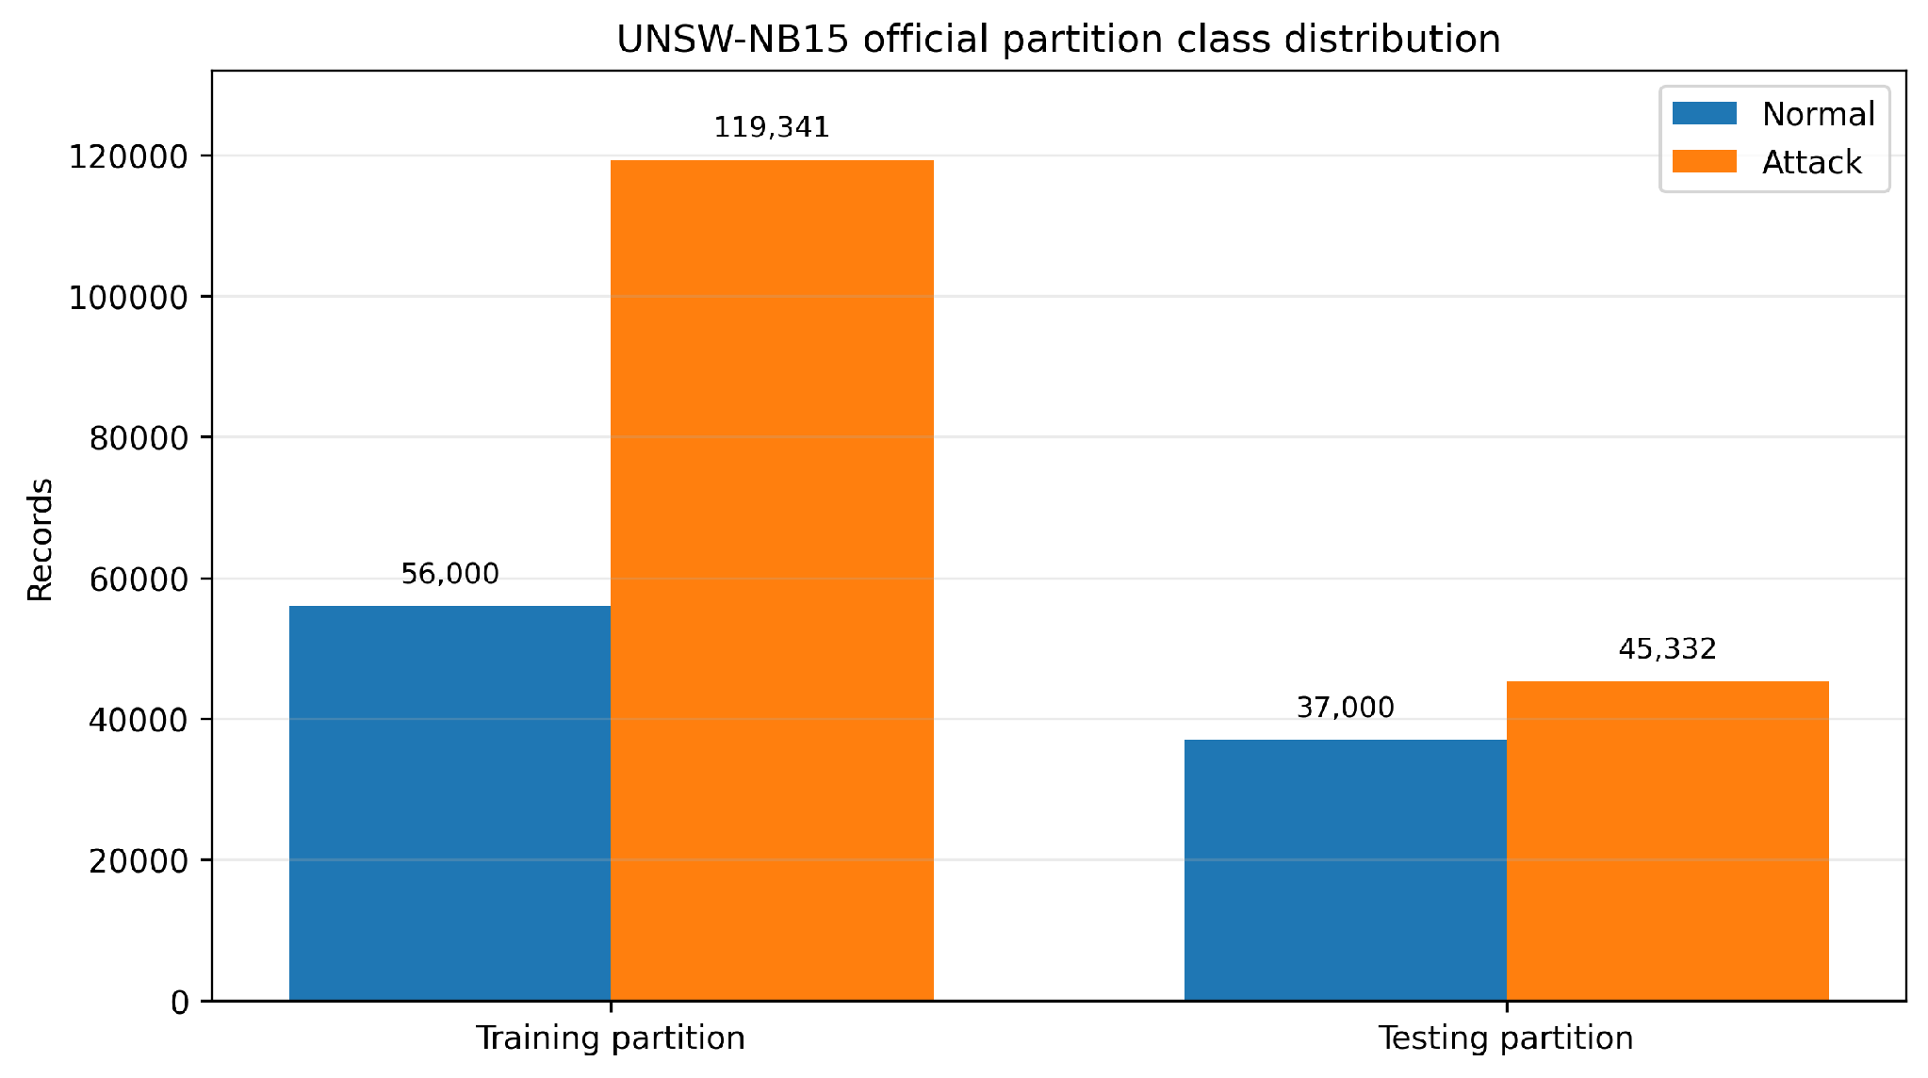
Figure 2. Normal and attack counts in the official UNSW-NB15 training and testing partitions.

5.5 Attack Categories
Category | Records (training) | Share of attack records
Generic | 40,000 | 33.5%
Exploits | 33,393 | 28.0%
Fuzzers | 18,184 | 15.2%
DoS | 12,264 | 10.3%
Reconnaissance | 10,491 | 8.8%
Analysis / Backdoor / Shellcode / Worms | 5,009 combined | 4.2%

Generic and Exploits are over 61% of all attacks. Worms has only 130 records, so any result for it rests on a very small sample. Our models are trained on normal traffic only and produce a binary decision, so these categories are not training targets.

5.6 Feature Structure
The 41 features cover flow basics (duration, protocol, service, state), volume (packets and bytes each way), rate (throughput and mean packet sizes), TCP behaviour (window sizes, sequence numbers, round-trip time), timing (inter-packet gaps and jitter), TTL-derived values, eleven connection-count features and two binary flags.
Three features are categorical: proto, service and state. The service field holds “-” in 53.7% of records, which means the service could not be identified. That is a real value, not a missing one, and I handled it as a category.

5.7 Class Distribution
Taken together the dataset holds 93,000 normal and 164,673 attack records. Only the normal ones are usable for training, because the models are one-class. The 56,000 normal training records are the entire supply I had to work with.

5.8 Dataset Strengths
- Ground-truth labels are supplied from the controlled benchmark-generation process, enabling repeatable evaluation against known normal/attack classes.
- It is widely used, so published results exist for comparison.
- The 93,000 supplied normal records provide a substantial normal sample for this prototype, although only the training-partition normals are eligible for source model development.

5.9 Dataset Limitations
- Synthetic. Generated traffic carries tool artefacts. The TTL features are unusually predictive for this reason, which is why I excluded them.
- Unrealistic class balance. Attacks outnumber normal traffic here; on a real network the reverse is true by orders of magnitude.
- The partitions differ. Six of 41 model-ready columns shifted significantly between training and testing.
- Heavy duplicate-equivalence and partition overlap. When id and attack_cat are ignored, 74,072 training rows and 28,380 testing rows participate in duplicate-equivalent groups. The audit also found 8,541 test rows overlapping the training partition, including 1,193 normal test records matching normal training records.
- Created in 2015. The benchmark remains useful for controlled comparison but cannot represent every current protocol, service, encrypted-traffic pattern or contemporary attack behaviour.

6. UNSW-NB15 Data Preparation
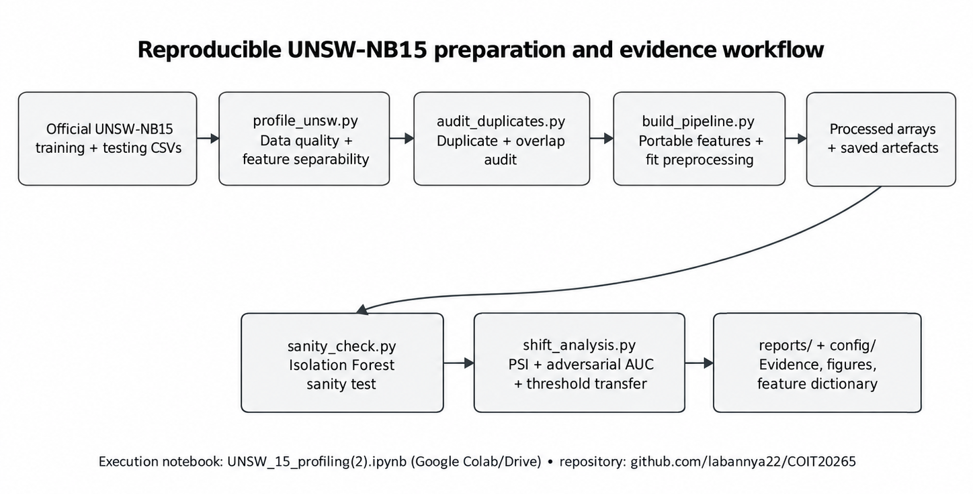
Figure 1. Reproducible UNSW-NB15 preparation and evidence workflow used in the supplied Google Colab notebook.
Figure 1 links the notebook execution to the script-level implementation and generated evidence. The notebook orchestrates the workflow; the substantive preparation logic is held in reusable Python modules so the process can be rerun without depending on transient notebook state.

6.1 Data Loading
Both files were loaded with pandas straight from CSV, with no options that would change values. Training came back as (175,341, 45) and testing as (82,332, 45). I checked the shapes immediately, which confirms the official partition was loaded.

6.2 Initial Data Inspection
Before changing anything I ran a profiling script that writes a report to a file rather than printing to the screen, so the findings survive a notebook restart. It records row and column counts, data types, class balance, attack counts, and which values appear in one partition but not the other.
Two findings changed later steps. The service field holds “-” in 53.7% of records, which is a real category rather than a missing value. And two connection states, ACC and CLO, appear only in the testing partition — so the encoder has to handle a category it never saw during fitting.

6.3 Data Cleaning
Cleaning was deliberately light, because every change I make here is a change the same pipeline must later make to other dataset traffic. I removed two columns: id, which is a row number and would let a model learn position instead of behaviour, and attack_cat, which would hand the model the answer.
I did not drop rows for being unusual. A flow with a very large byte count might be an attack, so removing outliers would remove exactly what the detector is meant to find.

6.4 Missing and Invalid Value Handling
Check | Result
Missing values (NaN) | None in either partition
Infinite values | None in either partition
Zero-duration flows | 2,657 rows

No imputation was needed. The zero-duration rows needed a decision, because rate, sload and dload are calculated by dividing by duration. The dataset authors had already resolved it — no infinite values appear — so I kept them as they are. I record it because the same situation will occur in other datasets too.

6.5 Duplicate Handling
Check | Result
Duplicate-equivalent rows in training (ignoring id/attack_cat) | 74,072 (42%)
Duplicate-equivalent rows in testing (ignoring id/attack_cat) | 28,380 (34%)
Test rows that also appear in training | 8,541 (10.37%)
Normal test rows copied from normal training rows | 1,193 (3.22%)

The cross-partition normal overlap is the most important leakage risk for this project. If duplicate-equivalent normal flows are present in both development and evaluation data, the model is judged on patterns already over-represented during fitting. That can make normal scores look artificially stable and can bias the operating threshold downward. The preparation therefore removes duplicate-equivalent normal records before the train/validation split and retains an overlap-reduced test variant for sensitivity checking.
So the rule was: remove duplicates before splitting, never after. I produced both a full and a deduplicated test set so results can be reported either way.
Interpretation limit: deduplicating the normal development partition before the train/validation split reduces within-development repetition, but does not by itself remove all possible overlap between that partition and the official test set. The separate deduplicated test variant and its comparison key must be documented when interpreting test outcomes. The full and deduplicated test sets also must not be silently substituted in published metrics.

6.6 Label Processing
The label went into its own array the moment the files loaded, and never touched the transformer at any point. This is deliberate — if the label stayed on the table, avoiding it would be something I had to remember at every later step. Taken out at the start, it is not there to forget.

6.7 Feature Selection
Feature selection was driven by the need to create a clean, consistent and deployable UNSW-NB15 feature set for the project’s anomaly-detection models. The original partition contains 41 model features, but not all of them were suitable for the final processing pipeline.
The selection process therefore considered three points: whether a feature represented meaningful network behaviour, whether it could be reproduced reliably in the project’s monitoring environment, and whether retaining it could introduce dataset-specific bias.
The final portable set contains 21 features.
Group | Features | Processing decision
Retained directly | dur, spkts, dpkts, sbytes, dbytes, proto, service | Retained because they describe basic connection, volume and protocol behaviour.
Retained as derived features | rate, sload, dload, smean, dmean, is_sm_ips_ports | Calculated from the retained connection-level fields.
Retained as recomputed context features | seven ct_* features | Kept because they capture recent connection behaviour, but are recomputed by the project pipeline.
Excluded | 21 features including sttl, dttl, swin and tcprtt | Removed because they depend on TTL, TCP-window, packet-level or dataset-specific information that was not suitable for the common processing design.
The most important exclusion was sttl. In the project’s separability analysis, sttl had an effect size of 1.94, making it one of the strongest individual features for separating normal and attack records. However, strong benchmark separation alone was not considered sufficient justification for keeping a feature.

TTL-related fields can reflect characteristics of the traffic-generation and capture environment as well as genuine network behaviour. A model that relies heavily on such a feature may achieve better results on UNSW-NB15 while learning behaviour that is specific to the benchmark rather than broadly useful anomaly patterns.
Evidence boundary for feature selection: the reported sttl effect size is a source-dataset association, not experimental proof that the measurement is an artefact of a particular traffic generator or that retaining it would necessarily harm every real network. Its exclusion is defensible as a portability precaution, but definitive deployment benefit requires a controlled feature-ablation or cross-domain comparison.
For that reason, sttl and the other non-portable fields were excluded even though this could reduce source-dataset performance. The project prioritised feature consistency, reproducibility and reduced dependence on benchmark-specific artefacts over maximising performance on UNSW-NB15 alone.
After feature selection, the 21 retained inputs were passed to the preprocessing pipeline. The 18 numerical features were transformed and scaled, while the three categorical features — proto, service and state — were encoded. This produced the final 41-column model-ready representation used for model development.
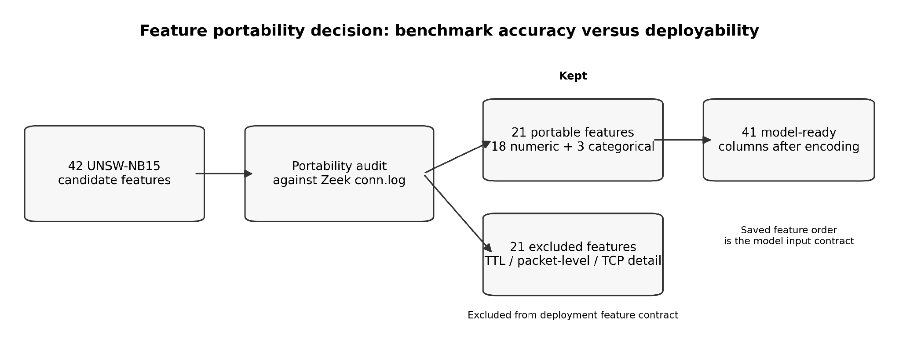
Figure 3. Deployment-driven feature portability decision: 41 benchmark features reduced to 21 portable inputs and 41 encoded model-ready columns.
The full feature-by-feature decision record is exported by the pipeline as config/feature_dictionary.csv. Keeping that machine-readable mapping with the source code provides stronger traceability than reproducing the same 41-row dictionary manually in this report.

6.8 Numerical Feature Processing
Eighteen of the 21 features are numeric and on wildly different scales — duration is often below one second, byte counts run to millions. A distance-based model would let byte count drown out everything else.
I applied log1p, which squashes large values down (a million becomes 13.8 while ten becomes 2.4), then standard scaling so every feature contributes on comparable terms. log1p rather than log because several features legitimately contain zero. Both were fitted on normal training data only.

6.9 Categorical Feature Processing
The three categorical features each carried a problem. proto has 133 distinct values, three of them appearing fewer than 50 times. service holds “-” in over half the records. state contains ACC and CLO in the testing partition only.
I grouped rare categories into a single “other” category and set the encoder to ignore unknown categories rather than raise an error, so an unseen state produces all-zero columns instead of crashing.

6.10 Encoding and Scaling
All preprocessing is encapsulated in one scikit-learn ColumnTransformer fitted on normal training data only and then saved. Validation, official test and future target-domain records are transformed with that fitted object; it is never refitted on evaluation data. This follows standard leakage-prevention practice: preprocessing parameters learned from test data can make evaluation optimistically biased even when the final estimator itself is unchanged (scikit-learn Developers 2026).
This rule matters more than it looks. If the transformer were refitted on test data, the scaling would be computed from traffic the model never trained on, and the two sources would stop being comparable — with no error message to reveal it.

6.11 Final 21 Portable Features
Type | Features
Numeric (18) | dur, spkts, dpkts, sbytes, dbytes, rate, sload, dload, smean, dmean, ct_srv_src, ct_srv_dst, ct_dst_ltm, ct_src_ltm, ct_src_dport_ltm, ct_dst_sport_ltm, ct_dst_src_ltm, is_sm_ips_ports
Categorical (3) | proto, service, state

6.12 Final 41 Model-Ready Features
After transformation the 21 features become 41 columns: 18 numeric columns plus 23 from one-hot encoding the three categorical features. Rare-category grouping is what keeps that number at 23 rather than several hundred.
41 is the number that matters operationally. Every model expects exactly 41 columns, in exactly one order.

6.13 Preprocessor Saving
File | What it holds | Why it matters
models/preprocessor.joblib | The fitted transformer | Must be loaded, never refitted
config/feature_order.json | The exact order of the 41 columns | The more important of the two
config/feature_dictionary.csv | All 41 features, status | Documents every selection decision

The column order file deserves the emphasis. If the lab data arrives in a different order, the model reads duration where it expects byte count. It does not crash and it does not warn anyone — it just gives confident, wrong answers.
The report records the resulting source-domain shapes as train (41,065 × 41), validation (10,266 × 41), test_full (82,332 × 41), and test_dedup (80,995 × 41). The supplied Colab notebook invokes build_pipeline.py and sanity_check.py rather than containing their full implementation. These dimensions therefore require corroboration with the generated files or script outputs before describing them as independently code-verified.

6.14 Processed Dataset Verification
Output | Shape | Contents
train_normal.npz | (41,065, 41) | Normal training records
val_normal.npz | (10,266, 41) | Normal validation, for threshold setting
test_full.npz | (82,332, 41) | The complete official test partition
test_dedup.npz | (80,995, 41) | Test partition with overlapping rows removed

The report records four quality checks: a 41-column model matrix, a declared order matching feature_order.json, split arithmetic (56,000 normal records reduced to 51,331 and split into 41,065 train / 10,266 validation), and exclusion of labels from features. The supplied notebook invokes external scripts to perform these steps; independent re-execution and dependency pinning cannot be established from that notebook alone.

7. Experimental Data Design

7.1 Normal-Only Training Principle
Every model here is one-class. It sees only normal traffic in training, learns a description of normal, and scores how far any new record sits from it. It is never shown an attack.
This was a choice, not a workaround. Labelled attack data is always incomplete, a real network has no labels at all, and what an organisation’s ordinary traffic looks like changes much more slowly than attack techniques do.

7.2 Training Set Preparation
Step | Records
Normal records in the training partition | 56,000
After removing duplicate rows | 51,331
80% taken as the training set | 41,065

The 4,669 records lost to deduplication are 8.3% of the normal supply. That is a real cost, but keeping them would have meant training on the same flow several times, which teaches the model that a repeated flow is especially normal.

7.3 Normal Validation Set Preparation
The remaining 20% became a 10,266-record normal validation set. Its downstream role is calibration rather than model fitting: later model/evaluation stages can score these normal records and derive a percentile-based source operating point, such as the 99th percentile for a nominal 1% upper-tail budget. The data-engineering artefact prepares and isolates this calibration set; final threshold selection and comparative testing are reported in the evaluation artefact.
These records are normal only, so no attack label is involved. That is what makes the method repeatable on a network where labels do not exist.

7.4 Test Set Preparation
Test set | Records | Composition
UNSW test_full | 82,332 | 37,000 normal, 45,332 attack
UNSW test_dedup | 80,995 | Same, with rows that also appear in training removed

7.5 Attack Records Reserved for Testing
All 119,341 attack records in the supplied training partition were excluded from model fitting and threshold calibration. This is deliberate: the experiment is designed to test normal-only/one-class detection, so using attack-labelled examples during fitting would change the learning problem and weaken the claim that detection does not depend on representative attack labels. Attack records are retained only for post-scoring evaluation.

7.6 Prevention of Data Leakage
# | Rule | What it prevents
L1 | Duplicates removed before the split | The same flow on both sides
L2 | Preprocessor fitted on training data only | Scaling computed from test data
L3 | Labels separated at load time | A label reaching the transformer
L4 | Thresholds set from validation normals only | A threshold tuned on the data it is judged against

L1 is the easiest leakage control to violate. If duplicate-equivalent normal flows are allowed on both sides of the split, validation contains patterns already over-represented during fitting. That can make normal scores look artificially stable and can bias the threshold downward. Removing duplicates before the split reduces this source of optimistic overlap before model fitting or threshold selection occurs.

7.7 Data Separation Verification
Check | Expected | Found
Training ∩ validation | 0 shared rows | 0
Attack records in training or validation | 0 | 0
Split arithmetic: 41,065 + 10,266 | 51,331 | 51,331
Column count and order in all files | 41, matching | Confirmed

The same separation rule carries into the evaluation artefact: a reported test result must not be measured on the same records used to choose its operating threshold.
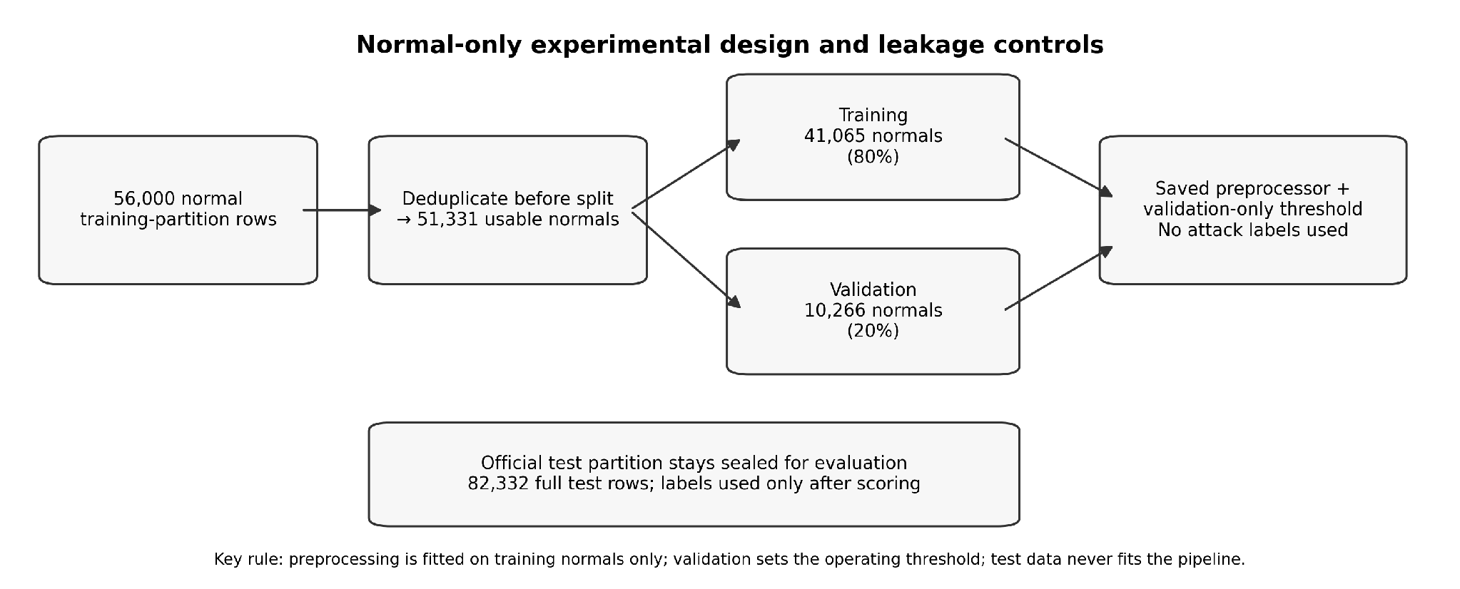
Figure 4. Normal-only split design and leakage-prevention boundaries for source-domain model development.

7.8 Reproducibility and Random Seeds
Seed 42 is used wherever randomness appears in this preparation workflow. The normal split is therefore repeatable, the preprocessor is fitted once and reloaded, the fixed model-input order is saved, package versions are pinned in requirements.txt, and generated reports/configuration files are exported rather than left only in notebook state. Final model thresholds belong to the evaluation workstream and should carry their own calibration provenance.
One limitation belongs here rather than at the end. I used seed 42 throughout and ran no multi-seed test, so the results are reproducible but I have not measured how much they would vary under a different split.

7.9 Implementation Environment, Code Provenance and Evidence Outputs
The supplied execution notebook was run in Google Colab and mounts the project from Google Drive at /content/drive/MyDrive/intentmap-nids. The notebook is an orchestration layer: it invokes reusable Python scripts, saves the fitted preprocessing artefact and configuration files, and writes evidence to reports/ rather than relying on cell output alone. The stable repository address recorded for this work is
Code-verification boundary (October 2026): UNSW_15_profiling(3).ipynb calls profile_unsw.py, audit_duplicates.py, build_pipeline.py, sanity_check.py and shift_analysis.py as external programs. The supplied notebook establishes the intended workflow and invocation order, but those script contents are not embedded in its code cells. Consequently, the precise duplicate keys, cross-partition overlap checks, feature transformations, random-seed propagation, software-version pinning and execution results cannot be independently verified from this notebook alone. Preserve the reports and derived outputs alongside these scripts to support reproduction; do not claim that the notebook alone proves the implementation.

https://github.com/Labannya22/COIT20265
The notebook file supplied for review is: https://colab.research.google.com/drive/1VnM7pjkWMbtrXp09ArDiDw1cesYUz-H5

Implementation module | Purpose in this artefact | Primary evidence/output
profile_unsw.py | Profiles shape, class balance, missing/invalid values and feature separability. | reports/data_quality_report.md; feature_separability.csv/png; core_feature_distributions.png
audit_duplicates.py | Audits within-partition duplicate-equivalent rows and train/test overlap. | reports/duplicate_audit.md
build_pipeline.py | Applies portable-feature selection, train-normal fitting, encoding/scaling and saved output generation. | models/preprocessor.joblib; config/feature_order.json; config/feature_dictionary.csv; reports/pipeline_report.md; processed arrays
sanity_check.py | Runs a lightweight Isolation Forest sanity check to verify score/threshold behaviour before full modelling. | reports/sanity_check.md; reports/sanity_check_scores.png
shift_analysis.py | Measures normal-partition shift using PSI and adversarial AUC and quantifies threshold-budget miss. | reports/shift_analysis.md; reports/feature_shift.csv; reports/distribution_shift.png
Evidence rule: figures and numeric claims in this artefact should be traceable either to the official raw partitions or to one of the generated report/configuration files above. Source code should be submitted through the project repository/ZIP, while large third-party datasets should be cited rather than bundled.

8. Verification and Quality Assurance
Nothing in this artefact was assumed. Each output was checked before the team was told it could be used.

8.1 Dataset Shape Verification
Dataset | Expected | Found | Pass
UNSW training partition | (175,341, 45) | Match | Yes
UNSW testing partition | (82,332, 45) | Match | Yes
train_normal.npz | (41,065, 41) | Match | Yes
val_normal.npz | (10,266, 41) | Match | Yes
test_full.npz | (82,332, 41) | Match | Yes
test_dedup.npz | (80,995, 41) | Match | Yes

The 45-column check on the raw files confirms the official partition was loaded rather than the full 2.54-million-record version, which has 49.

8.2 Feature Count and Order Verification
21 portable features expand to 41 model-ready columns. I checked the count on every output file, and compared the column order against config/feature_order.json.
The order check matters more than it looks. A mismatch raises no error — the model simply reads duration where it expects byte count and returns confident, wrong answers. Exact match on all four files.

8.3 Split Arithmetic Verification
Check | Expected | Found
Normal records in the training partition | 56,000 | 56,000
After duplicate removal | 51,331 | 51,331
80% training split | 41,065 | 41,065
20% validation split | 10,266 | 10,266
41,065 + 10,266 | 51,331 | 51,331

8.4 Leakage Verification
Check | Expected | Found
Records shared between training and validation | 0 | 0
Attack records in the training set | 0 | 0
Attack records in the validation set | 0 | 0
Label column present in any feature file | No | No
Preprocessor refitted after the training fit | No | No

8.5 Distribution Shift Check
I ran a shift analysis between the training and testing partitions, because a dataset is not automatically internally consistent just because it comes from one source.
Measurement | Result
Features with PSI above 0.25 (significant shift) | 6 of 41
Most shifted feature | dload (PSI 0.394)
Adversarial AUC between partitions | 0.641
Character of the shifted features | All six describe traffic volume

An adversarial AUC of 0.641 means a classifier can tell the two partitions apart better than chance, so they are not drawn from the same distribution. The practical consequence is observable even before full model comparison. An Isolation Forest sanity check calibrated for a nominal 1% false-positive budget on source validation normals produced 2.13% FPR on the official test partition. The estimator and preprocessing were unchanged; only the normal-score distribution moved. This result motivates the later cross-domain threshold-transfer and target-normal recalibration experiments.
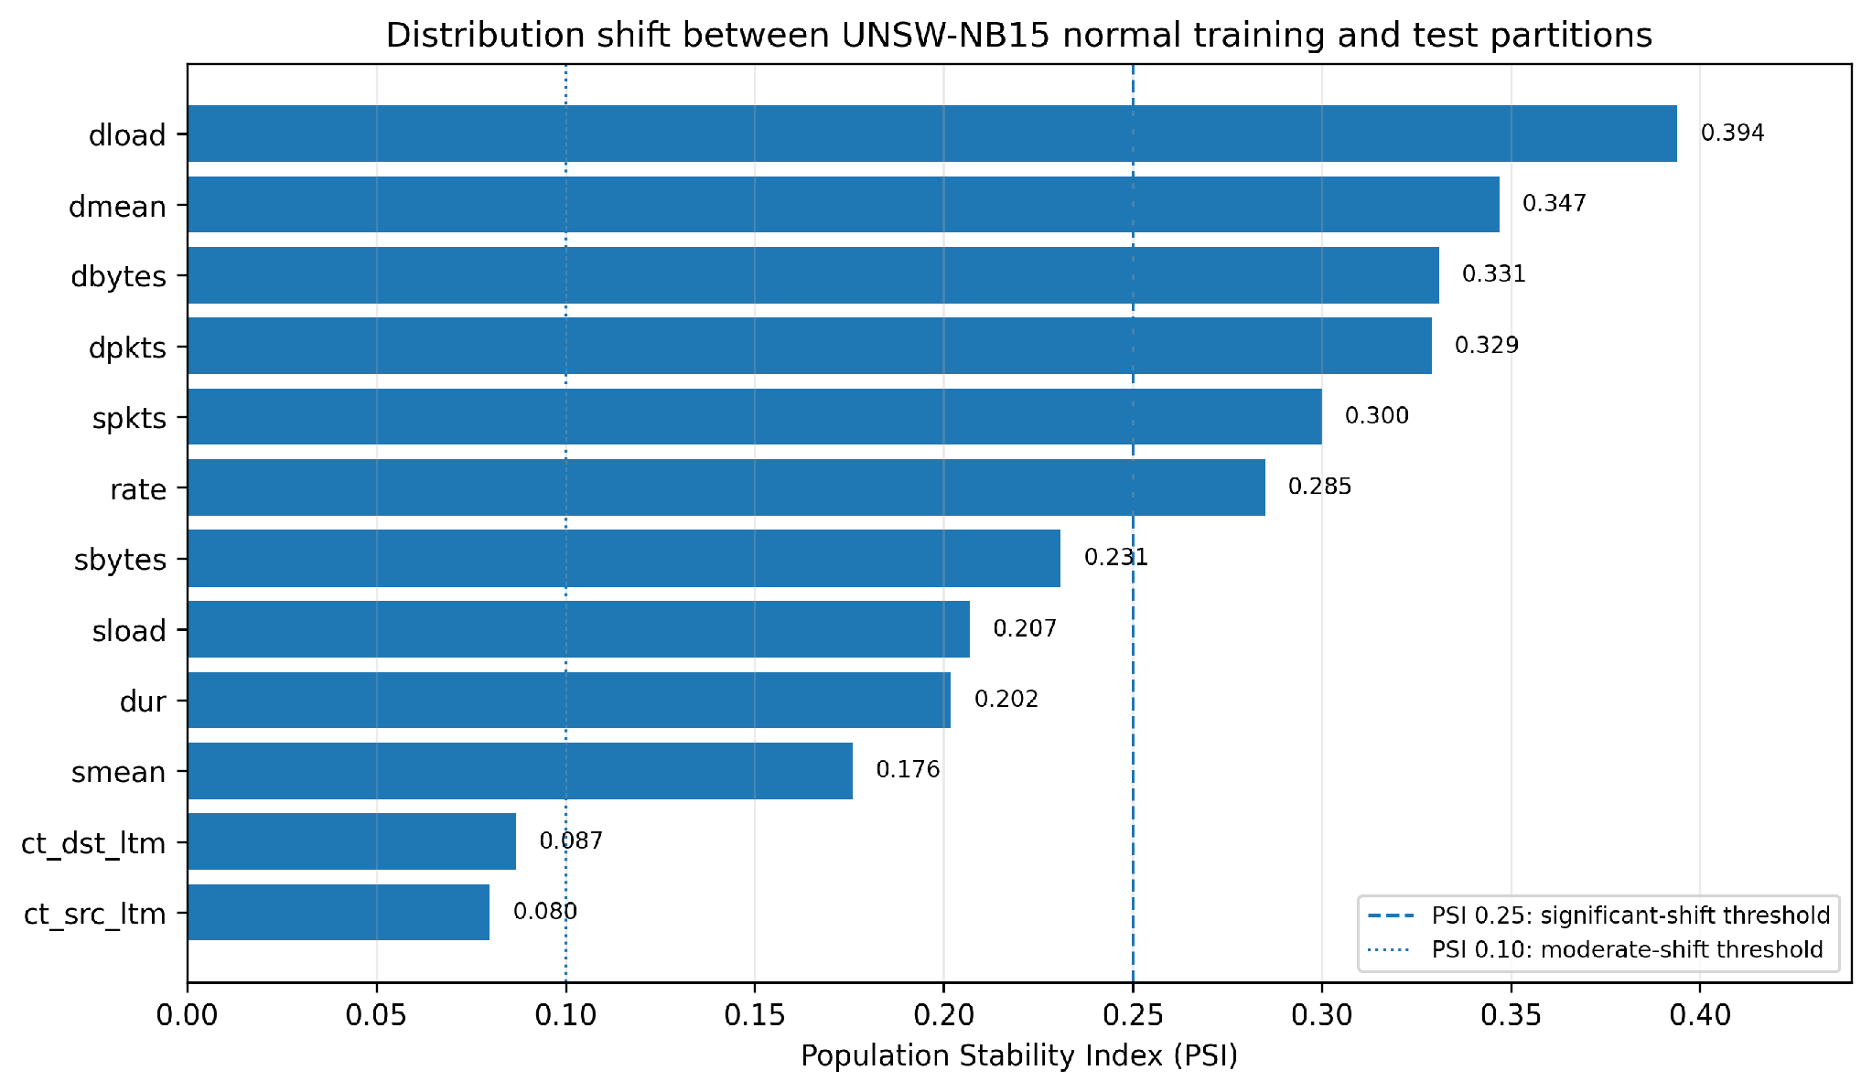
Figure 5. PSI values reported by shift_analysis.py for the most shifted model-ready features; six exceed the 0.25 significance rule used in the project analysis.

8.6 Reproducibility Verification
Control | Status
Random seed 42 | Set in every script
Train/validation split | Fixed — identical records on every run
Preprocessor | Saved to models/preprocessor.joblib, reloaded thereafter
Feature order | Stored in config/feature_order.json
Feature decisions | Stored in config/feature_dictionary.csv
Package versions | Pinned in requirements.txt
Outputs | Four .npz arrays plus report files

8.7 Requirements Verification
ID | Requirement | Evidence | Met
DR1 | Normal records only in training and validation | Section 9.4 | Yes
DR2 | Only Zeek-producible features | Section 7.7, 7.11 | Yes
DR3 | Duplicates removed before the split | Sections 7.5, 8.6 | Yes
DR4 | Label and id removed before transformation | Sections 7.3, 7.6 | Yes
DR5 | Feature set and order fixed and saved | Sections 7.13, 9.2 | Yes
QR1 | Quality problems written to report files | Section 7.2 | Yes
QR2 | Duplicate overlap counted | Section 7.5 | Yes
QR3 | Missing and infinite values checked | Section 7.4 | Yes
QR4 | Unseen categories identified before encoding | Sections 7.2, 7.9 | Yes
LR1 | No record in both training and validation | Section 9.4 | Yes
LR2 | Preprocessor fitted once on training data | Sections 7.10, 9.4 | Yes
LR3 | Label separated at load time | Section 7.6 | Yes
LR4 | Partition overlap measured and reported | Section 7.5 | Yes
RR1–RR5 | Reproducibility controls | Sections 8.8, 9.6 | Yes

9. Critical Evaluation

9.1 Key Findings
1. Duplicate-equivalent records are prevalent: 74,072 training rows were members of repeated-pattern groups under the project audit definition; separately, the reported cross-partition audit identified 1,193 normal test records matching training records. Group membership counts must not be interpreted as the number of rows removed.
2. Only half the feature set is portable. 21 of 41 features need TTL values or packet inspection.
3. The most separable feature is the least trustworthy. sttl has an effect size of 1.94 because the generating tool left a fingerprint in the TTL values.
4. The two partitions are measurably different. Six of 41 columns shifted, adversarial AUC 0.641, and a 1% calibration produced 2.13%.

10. Limitations

10.1 Dataset Limitations
- Synthetic traffic. Generated by IXIA PerfectStorm, not captured from a production network, so it carries tool artefacts.
- Unrealistic class balance. Attacks are 55% of the testing partition; on a real network they are a fraction of a percent.
- Uneven attack categories. Worms has 130 records against Generic’s 40,000.
- • Created in 2015. UNSW-NB15 remains useful for controlled comparison, but its traffic generation and service mix cannot represent every current protocol, encrypted-traffic pattern or contemporary attack behaviour.

10.2 Feature Selection Limitations
- The portability mapping is project-specific and was derived from UNSW-NB15 feature definitions and Zeek conn.log semantics rather than from a one-to-one replay of every source feature. Seven ct_* features are recomputed by the project over a defined connection window and should be validated further against equivalent traffic scenarios.
- No feature-level ablation. I did not measure what each excluded feature would have contributed, only that sttl was the strongest.
- Rare-category grouping is a judgement call. I grouped protocols appearing fewer than 50 times into “other”; a different cut-off would produce a different column count.

10.3 Preparation Limitations
- Light cleaning by design. I removed no outliers, because an unusual flow might be the attack. That leaves genuinely odd records in the training data.
- One seed. The documented preprocessing split uses seed 42. Multi-seed variance was not measured, so stability across different random splits has not been established.
- No cross-validation. A single 80/20 split, not a k-fold design.
- The deduplicated test set was produced but is not the default. Results can be reported either way, which is a choice left to whoever reports them.

11. Recommendations
Four recommendations follow from the preparation work, for the team and for anyone reusing this pipeline.

11.1 Validate Recomputed Context Features
The seven ct_* features were retained because they capture useful recent-connection behaviour, but they are not simple raw fields. They depend on how neighbouring connections are counted over a defined window.For the UNSW-NB15 preparation, these features should therefore be treated as derived context features whose definitions must remain consistent with the original benchmark semantics. Their formulas, counting rules and window assumptions should be documented clearly and checked against the UNSW-NB15 feature descriptions before they are reused in later stages.
This reduces the risk of creating values that have the same column names but represent a different behavioural meaning.

11.2 Define a Zero-Duration Handling Rule
The UNSW-NB15 partitions contain 2,657 zero-duration records. This matters because several derived variables, including rate-related features, depend on duration.
The supplied dataset already contains finite values for these records, so no additional correction was required during the current preparation stage. However, the preprocessing logic should document an explicit zero-duration handling rule so that future reprocessing remains consistent and does not introduce division-by-zero errors or inconsistent rate calculations.
The rule should be recorded as part of the preprocessing specification rather than relying on the behaviour of the distributed CSV files alone.

11.3 Report Both Test Sets
The full test set (82,332) and the deduplicated one (80,995) give different results, because 1,193 normal test records are copies of training records. Whoever reports model performance should state which set was used, and ideally both.

11.4 Re-run the Shift Analysis on Any New Data Source
The shift check in Section 9.5 took one script and produced the most consequential finding in this artefact. It should be run whenever a new traffic source enters the project, before any threshold is calibrated on it.

11.5 Collect More Normal Traffic Than Seems Necessary
Deduplication removed 8.3% of a supply that was already limited to 56,000 records. For the lab capture, collecting substantially more normal traffic than the minimum is cheap insurance, because the usable amount is always smaller than the captured amount.

12. Conclusion
This artefact establishes the source-domain data contract used by the modelling and evaluation workstreams. It converts the official UNSW-NB15 partitions into a reproducible normal-only development set, a fixed 41-column model input, and saved preprocessing/configuration artefacts that can be reused without refitting.
Three engineering decisions are central to the outcome: duplicate-equivalent normal records are removed before the train/validation split; feature selection is constrained by what the Zeek deployment pathway can reproduce; and attack-labelled records are excluded from model fitting so the experiment remains genuinely normal-only/one-class. These choices deliberately prioritise evaluation integrity and deployment compatibility over maximising benchmark-only performance.
A further contribution is the measured source-partition shift. Six model-ready features exceed the project PSI significance threshold, the adversarial AUC between normal training and test partitions is 0.641, and a nominal 1% validation calibration yields 2.13% FPR on the official test partition. This demonstrates that even within one benchmark, a threshold can fail to transfer exactly when the normal-score distribution changes.

13. References
Cantone, M., Marrocco, C. & Bria, A. (2024) 'On the cross-dataset generalization of machine learning for network intrusion detection', IEEE Access, 12, pp. 144489-144508.
Moustafa, N. & Slay, J. (2015) 'UNSW-NB15: a comprehensive data set for network intrusion detection systems', 2015 Military Communications and Information Systems Conference (MilCIS), pp. 1-6.
Sarhan, M., Layeghy, S. & Portmann, M. (2022) 'Towards a standard feature set for network intrusion detection system datasets', Mobile Networks and Applications, 27. doi:10.1007/s11036-021-01843-0.
scikit-learn Developers (2026) 'Common pitfalls and recommended practices: data leakage and inconsistent preprocessing', scikit-learn documentation. Available at: https://scikit-learn.org/stable/common_pitfalls.html (accessed 8 October 2026).
Sommer, R. & Paxson, V. (2010) 'Outside the closed world: on using machine learning for network intrusion detection', 2010 IEEE Symposium on Security and Privacy, pp. 305-316.
Tavallaee, M., Bagheri, E., Lu, W. & Ghorbani, A.A. (2009) 'A detailed analysis of the KDD CUP 99 data set', 2009 IEEE Symposium on Computational Intelligence for Security and Defense Applications, pp. 1-6.
UNSW Research (n.d.) 'The UNSW-NB15 Dataset'. Available at: https://research.unsw.edu.au/projects/unsw-nb15-dataset (accessed 8 October 2026).
Zeek Project (2026) 'conn.log and connection logging', Book of Zeek. Available at: https://docs.zeek.org/en/current/reference/logs/conn.html (accessed 8 October 2026).

